I tried to download repository as it had written.
To download repository we should add suffix /zipball/master/ to url line.

[support@centos00 test]$ curl -x http://monitoring2.tcsbank.ru:8080 -L -o master.zip http://github.com/lausser/check_hpasm/zipball/master/

% Total % Received % Xferd Average Speed Time Time Time Current
Dload Upload Total Spent Left Speed
100 64202 100 64202 0 0 42784 0 0:00:01 0:00:01 --:--:-- 62090
[support@centos00 test]$

[root@vm-ossec01t html]# curl -x http://nag2.tcsbank.ru:3128 -L -o master.zip http://github.com/ECSC/analogi/zipball/master/
% Total % Received % Xferd Average Speed Time Time Time Current
Dload Upload Total Spent Left Speed
139427 124 139427 136k 0 0 38016 0 --:--:-- 0:00:03 --:--:-- 74400
[root@vm-ossec01t html]# ls -Alh
total 140K
-rw-r--r-- 1 root root 137K May 7 17:13 master.zip
[root@vm-ossec01t html]#

Or like follow.
yum install git-core
git clone https://github.com/ECSC/analogi.git

[root@admingate ~]# yum install tig

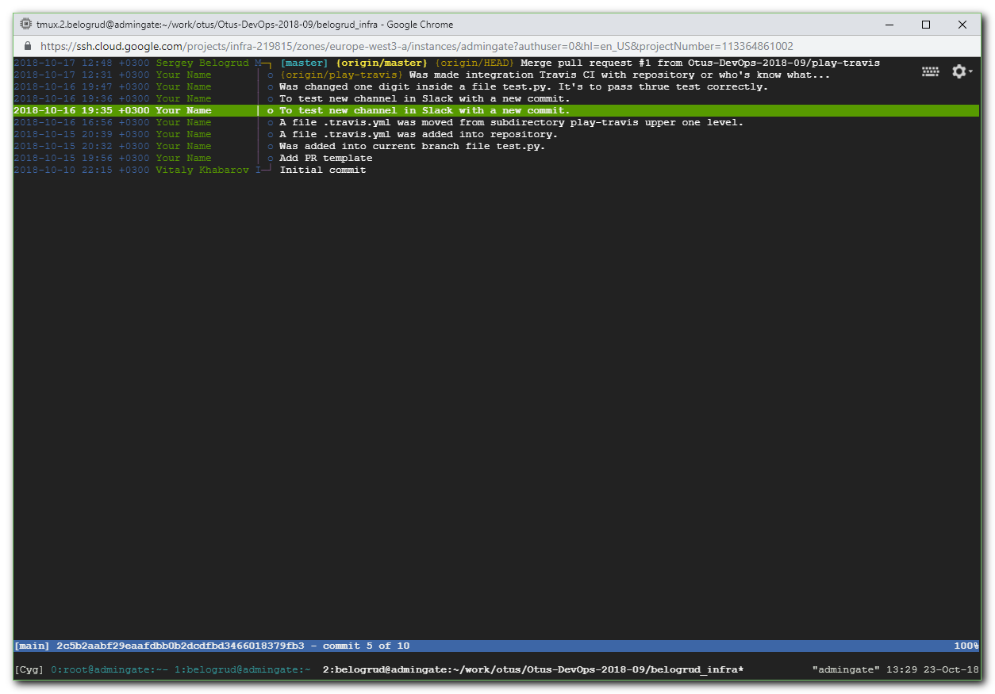

http://www.beatofthegeek.com/2014/01/git-commit-illustrated-simplicity.html

git commit illustrated: Simplicity revealed by a complex exercise for simplest git task
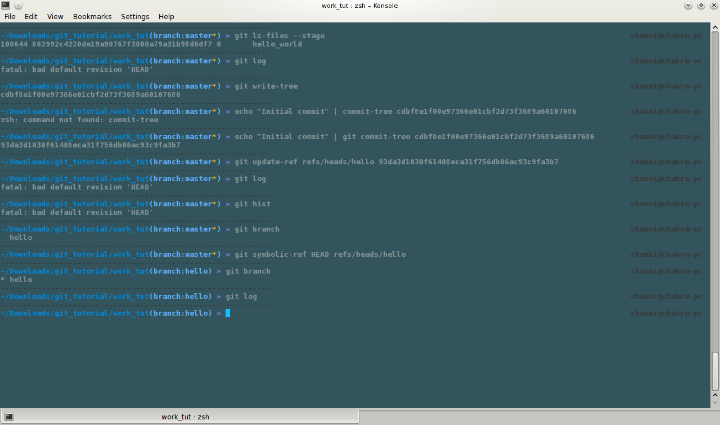
In this post I will try to explain the underlying commands and to a level the internal working of the git system involved when making a 'commit'.
This post is actually the by-product of my research for another post about git (.git/ actually). I was so much astonished by the amount of myths about complexity of git system removed from my mind, that I decided to make it the today's post itself. To me the git system appears much simple now than yesterday.

Commit
Commit is the central piece of the git system. The git world is simply a collection of commit objects, each of which hold a tree, which hold references to other trees and blobs. The branches, the tags, the HEAD are just fancy aliases for commits (more on these in some other post (next may be)).
A commit is basically the snapshot of present working tree. I will spare the details for a future post (it's worth it).

Let's now discuss what this post is about. Revealing the secrets involved in every git users ritual of 'commit'ing, and performing a commit manually.

This should reveal quite some details about the internal working of git (no you don't need to run away, it's not that deep).

You might already know the concepts, but knowing sex and having sex are kind of different things.

Ok! Let's start the exercise for manual commit.

First we need to create an empty directory, call it 'work'. And some simple file in it.
=> mkdir work
=> echo "Hello world!" > hello_world
Initiate a git repo in it and add the 'hello_world' file
=> git init
We will keep an eye on the changes that happen in the '.git' repo throughout our exercise. For now check out what's saved in the HEAD.
=> cat .git/HEAD
=> ref: refs/heads/master
As HEAD is basically just a reference to the commit which represents the current commit associated with the working tree. So one might guess .git/refs/heads/master would point to the tip of a branch. Let's check it
=> ls .git/refs/heads/master
=>
=> git branch
=>
There is nothing in there. Since we have not committed any commits yet, there are no branches (since branches are merely named commits which happen to have multiple child commits).
If you are feeling adventurous, you can try 'git log'.
=> git log
=> fatal: bad default revision 'HEAD'
Let's now add our file to the staging area
=> git add hello_world
Staging area is the middle system which keeps our content after 'git add' and before 'git commit'
A blob is the git's representation of a file. It's not actually a file, but just the content. A blob do not have any name or other metadata. It's referenced in trees which contain metadata for blobs.
Tree is the object which stores references to other trees and blobs as leaf nodes.
This command converted content of 'hello_world' file into a blob and placed it in the index (aka staging area). A 'blob' is how our content is represented in git. You can check the .git dir, a new file 'index' is created. This file contain the references to all blobs and trees which get added to our staging area.
=> ls .git
=> branches config description HEAD hooks *index* info objects refs
At this point we would generally just 'commit' the 'index', but not this time. The 'git commit' command hides many details and is a great convenience. You'll value it after this exercise.

Git store all our content in form of blobs. The blobs do not have any kind of meta-data attached with them (like name, creation date or something). They are just nameless 'blobs'. To identify a blob, they are saved in 'trees' as leaf nodes. Different trees can save reference to same blob with different meta-data attached. But a git repository will have exactly one copy of a blob. This is the reason of compact storage of git.

We can see the blob for our content in 'hello world' present in staging area (index)
=> git ls-files --stage
=> 100644 802992c4220de19a90767f3000a79a31b98d0df7 0 hello_world
If you entered the same content as me, both your and my hashes should be same. We can check what type of object the above hash belong to
=> git cat-file -t 802992c
=> blob
The above blob is not referenced by any tree. It's only referenced from .git/index (which store references to objects (blobs and trees) which make up our staging area).
A 'commit' object in git holds a single tree. A tree may have references to more trees or blobs. So to 'commit' the above created blob of our content, we need a tree.

So we now need to create a tree.
=> git write-tree
=> cdbf8e1f00e97366e01cbf2d73f3689a60107686
'write-tree' command make a tree with the contents of the 'index'.
Now when we have the tree, let's create a commit object with it.
=> echo "Initial commit" | git commit-tree cdbf8e1
=> a5a86835ba72e3ca7d5267c68c06c212392f9b7d
That's the hash for our commit object. You directly use 'git commit '. Then the command will wait for the commit message to be entered and 'ctrl-d' for proceeding.

So our commit object is ready, and we are done. Right? Not actually. What we have created is called an 'unreachable commit'.
An unreachable commit is a commit which do not have any parents and which is not referenced by any of the files in .git/refs/heads/. Such commits are automatically removed by the git system after some time.
To make our commit reachable, we need to create a reference in a file in .git/refs/heads.
=> echo a5a86835ba72e3ca7d5267c68c06c212392f9b7d > .git/refs/heads/hello
Actually we should instead use the more safe way to update references in git system.
=> git update-refs refs/head/hello a5a86835ba72e3ca7d5267c68c06c212392f9b7d
Here if we had used name 'master' instead of 'hello', we could have used 'git log'. But now it's still giving 'fatal:' because the HEAD is referring to 'refs/heads/master' which does not exist.

Now try the command 'git branch'.
=> git branch
=> hello
Here we see what a branch actually is to git. A reference to a 'commit' object.
Wait there is more to it. Now when we have created the branch 'hello', we need to make HEAD refer to it.
=> git symbolic-ref HEAD refs/heads/hello
This command associated our working tree with the newly created branch/commit of ours. This is what actually happens on a checkout normally.
Now we can use 'git log'. If you are using 'zsh' with appropriate theme, at this point the git branch indicator will change form uncommitted 'master' to committed 'hello'.

Now we are done. Officially. Git system is this frighteningly simple inside. Hope this was as helpful for you as it was for me. I really enjoyed writing this post.

http://stackoverflow.com/questions/2751227/how-to-download-source-in-zip-format-from-github

How to download source in .zip format from GitHub?
up vote
134
down vote
favorite
29
I see something strange like:

http://github.com/zoul/Finch.git

Now I'm not that CVS / SVN / etc. dude. When I open that in the browser it tells me that I did something wrong. So I bet I need some hacker-style tool? Some client?

(i mean... why not just provide a zip? isn't the world complex enough?)

git github
share|improve this question
edited Oct 14 '13 at 23:54

Manav Kataria
881715
asked May 1 '10 at 19:06

dontWatchMyProfile
9,1262598199

Easiest link for getting git itself by source is probably code.google.com/p/git-core/downloads/list – mikebabcock Nov 7 '12 at 23:38

Sir What is this " zipball " ... if i will download CakePHP from "github.com/cakephp/cakephp/zipball/2.3.2 " then it is possible this will be different than the official version ?? – Puzzled Boy Aug 16 '13 at 6:10
add comment
5 Answers
activeoldestvotes
up vote
131
down vote
accepted
Please Note: This is deprecated as of September 2013. See revised answer here.

Have a read through http://help.github.com/

To clone that repository via an url like that yes you do need a client, that client is git. That will let you make changes, your own branches, merge back in sync with other developers, maintain your own source that you can easily keep up to date without downloading the whole thing each time and writing over your own changes etc, a zip wont let you do that.

It is mostly meant for people who want to develop the source rather than people who just want to get the source one off and not make changes.

But it just so happens you can get a zip as well:

Click on http://github.com/zoul/Finch/ and then click on ZIP button just to the left of the repository URL field. See here:

enter image description here

share|improve this answer
edited Oct 22 '13 at 21:29

ean5533
4,89211337
answered May 1 '10 at 19:15

Kurt
2,67911022
7
THANKS man, you saved my weekend! I almost thought I had to go through all this complexity just to get a download. oh man. wtf. thanks. – dontWatchMyProfile May 1 '10 at 20:10

Ehm, I'm checking github.com/zoul/Finch now, and there is no "Download Source" button... Do you have to be logged in to see it, or has it been removed? – sdaau Jul 15 '11 at 11:12
2
@sdaau There's a big Downloads button on the right side whether you are logged in or not. Click it, and it will give you options to DL .tar.gz or .zip. – Sammy Larbi Aug 11 '11 at 15:03
4
now the button for downloading is quite small and located left from the repository URL field, it says "ZIP". had a hard time to find it :s – mmoossen Jan 2 '12 at 9:49
1
Now the download button is in the right column at the bottom... – mattdlockyer Feb 6 at 21:55
show 7 more comments
up vote
102
down vote
What happens when the repository owner has not prepared a zip file?! and you just want a download to use yourself! there is an answer and you don't need to go though that horrid process to download software, install and register keys and what not on github etc!

to simply download a repository as a ZIP file: add the extra path '/zipball/master/' to the end of the repository URL and wallah it gives you a zip of the whole lot.

for example:

http://github.com/zoul/Finch/

becomes:

http://github.com/zoul/Finch/zipball/master/

it then gives you a zip file to download.

share|improve this answer
answered Aug 13 '11 at 4:02

user892731
1,021142
1
THANK YOU! I needed to download code from a repository that didn't have a zip file, and this worked perfectly. I would have never figured out what I'm doing from the github help. – weronika Sep 26 '11 at 19:12
2
Awesome info my friend. There have been many times where I have wanted to download different branches without having to install git. Honestly I don't understand why there just isn't a link for this... – Zaptree Dec 10 '11 at 3:20
7
I think this is even better then the answer marked as answer. – SwissCoder Feb 8 '12 at 16:00
2
Wish this worked, but no luck here: github.com/facebook/php-webdriver --when I add "zipball/master/" to the end of that URL, I just get an error message. I'm echoing the original commenter... I just don't understand why it's so f'ing hard to download source code I see on github. I don't want a git client, I don't want to learn git, I just want to pull down the files that are right in front of my face :-) – Eric Feb 16 '12 at 0:45
2
@Eric - it worked for me: github.com/facebook/php-webdriver/zipball/master – Steve K Apr 23 '12 at 23:25
show 4 more comments
up vote
44
down vote
As of September 2013, the Download ZIP button has moved to bottom-right of page:

Download ZIP (2013)

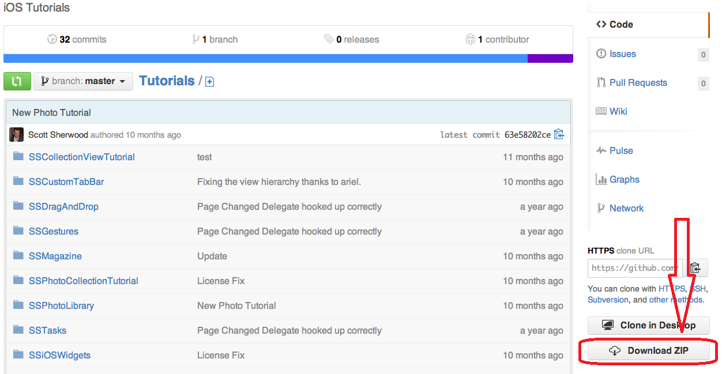

If you don't see the button:

Make sure you've selected <> Code tab from right side navigation menu, or
Repo may not have a zip prepared. Add /zipball/branch/ to the end of the repository URL and to generate a zipfile of the master branch.

http://github.com/user/repository/

-to-

http://github.com/user/repository/zipball/master/
to get the master branch source code in a zip file.

share|improve this answer
edited Jan 23 at 21:18

answered Sep 3 '13 at 4:13

Manav Kataria
881715
add comment
up vote
6
down vote
Here's a good reference if you want to do it from the command line: http://linuxprograms.wordpress.com/2010/10/26/checkout-code-from-github/

Basically it's

git clone http://github.com/zoul/Finch.git
share|improve this answer
answered Sep 20 '13 at 4:51

Paul Baumer
6111
add comment
up vote
3
down vote
To download your repository as zip file via curl:

curl -L -o master.zip http://github.com/zoul/Finch/zipball/master/
If your repository is private:

curl -u 'username' -L -o master.zip http://github.com/zoul/Finch/zipball/master/
Source: Github Help

share|improve this answer
answered Aug 14 '13 at 2:39

Willy
1,11021420

sweet! worked like a charm, I had permission limits in a batch system with no browser and this one was what I needed! – userHoofarthirtysevenfive Jan 10 atqq 22:30

#
# 20181107
#

https://learngitbranching.js.org/

